Assignment Module 2 CSS

Q1. What are the benefits of using CSS?
Ans. CSS separates the content and design (visual appearance) of html document, hence it is easier to make any updates in design or in content.
CSS helps to apply uniform styles across multiple web pages.

Q2. What are the disadvantages of CSS?
Ans. Display of web pages may be inconsistent depending on how the browser interprets CSS rules. CSS can be very complex and confusing when dealing with multiple style sheets.

Q3. What is the difference between CSS2 and CSS3?
Ans. CSS3 is the latest version, which has many new features and improvements over CSS2. CSS3 supports more browsers than CSS2. CSS3 is faster and more efficient than CSS2.

Q4. Name a few CSS style components?
Ans. Examples of CSS style components are: background, text-align, color, height, width, border, position, display, margin, padding, etc.
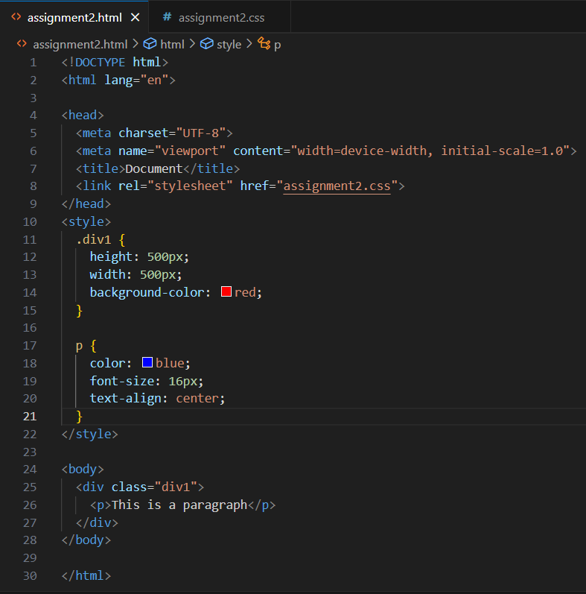

Q5. What do you understand by CSS opacity?
Ans. CSS opacity sets the transparency level of an element from 0 (fully transparent) to 1 (opaque). Opacity is used for creating visual effects such as fading, blending or overlaying.

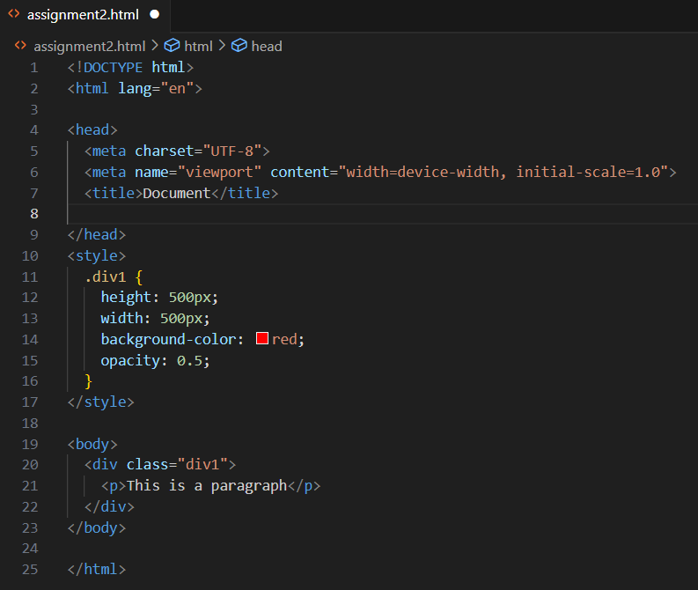

Q6. How can the background color of an element be changed?
Ans. The background color of an element be changed by using “background-color” property of the CSS. Colors can be specified in different ways, such as keywords, hexadecimal, RGB, RGBA or HSL.
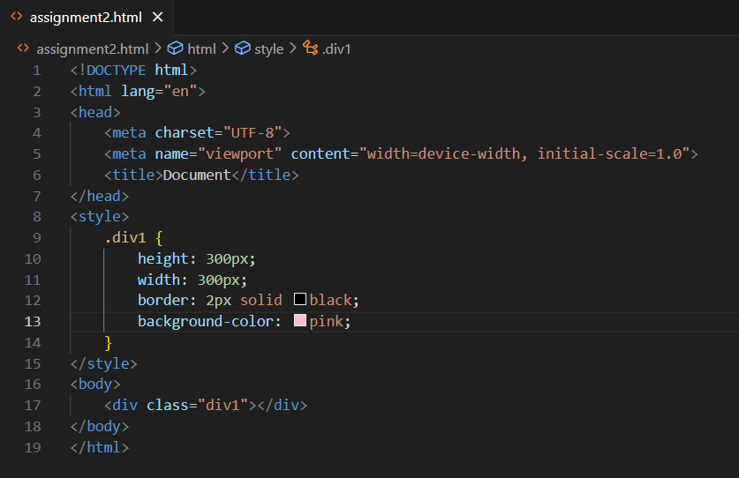

Q7. How can image repetition of the backup be controlled?
Ans. It can be controlled using “background-repeat” property in CSS. This property will specify how the background image is repeated, horizontally, vertically or not at all.

Q8. What is the use of the background-position property?
Ans. Background-position property is used to adjust the position of the background image.
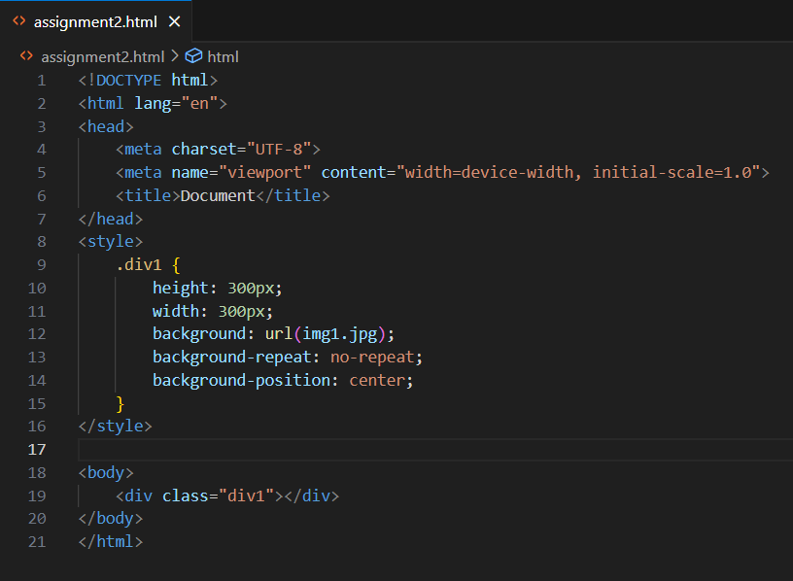

Q9. Which property controls the image scroll in the background?
Ans. CSS property “background-attachment” controls the image scroll in the background. It has three values, scroll, fixed or local.

Q10. Why should background and color be used as separate properties?
Ans. Background property is complex that can set multiple aspects of the background, such as image, position, size, repeat, etc. Color property is simple that can only set the text color. Combining them would make the syntax more complicated and confusing.

Q11. How to center block elements using CSS1?
Ans. Block level elements such as <div>,<p>,etc can be entered horizontally by setting their margin property to auto.
We can also apply display: flex to a container, we can use justify-content: center to horizontally center its child elements.

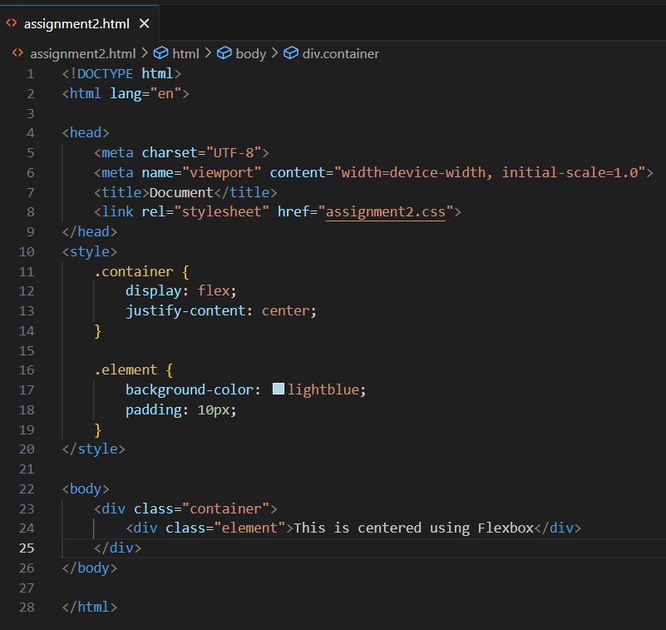

Q12. How to maintain the CSS specifications?
Ans. Follow existing style guidelines for CSS if available over personal preferences.
Maintain consistent naming conventions for classes.
Choose a formatting style that is more readable, such multi-line formatting.
Adding comments to CSS so that future developers can easily understand the code.

Q13. What are the ways to integrate CSS as a web page?
Ans. Inline style - adding CSS rules directly to an HTML element using the style attribute.
Internal CSS - it is within the <style> tag in the <head> section of an HTML document.
External CSS involves defining CSS styles in a separate file, usually with a .css extension.

Q14. What is embedded style sheets?
Ans. Embedded style sheets are a way of applying CSS styles to an HTML document by using <style> element in <head> section. It useful for styling a document that has unique style requirements.

Q15. What are the external style sheets?
Ans. External style sheets are files that contain CSS rules that can be applied to multiple HTML pages. External style sheets have .css extension and are linked to HTML documents using <link> element in <head> section.
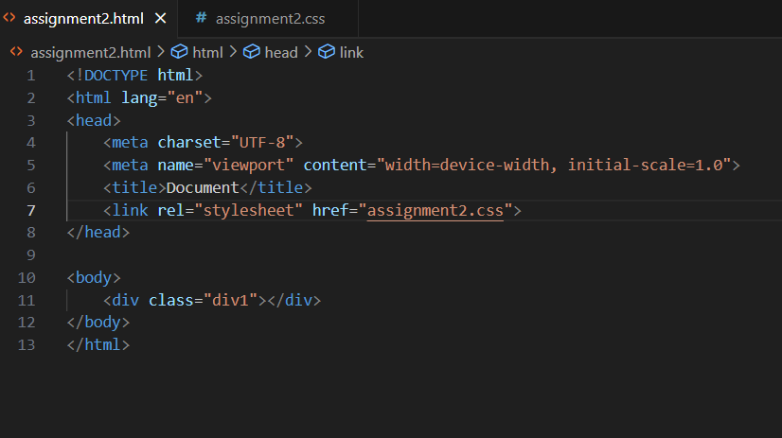

Q16. What are the advantages and disadvantages of using external style sheets?
Ans.
Advantages:
They improve maintainability and code organization, as you can edit the style of multiple pages from one file.
They enhance reusability across multiple HTML files.
We can link the same style sheet to different pages.

Disadvantages:
They may cause pages to not render correctly until the external style sheet is loaded.
They may increase the site’s download time.

Q17. What is the meaning of the CSS selector?
Ans. A selector can be based on the element name, id, class, attribute, pseudo-class, pseudo-element, or a combination of these. A selector is followed by a declaration block that contains the CSS properties and values to apply to the selected elements.
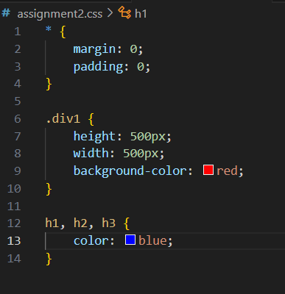

Q18. What are the media types allowed by CSS?
Ans. The all media type applies to all devices.
The print media type, targets print preview mode or when we try to print a web page.
The screen media type, is used for computer screens, tablets, smartphones, and other display devices. It is the most common media type for styling web pages.

Q19. What is the rule set?
Ans. CSS rule set, defines how an HTML element should be styled.
It consists of a selector, which identifies the HTML element and a declaration block, which contains one or more property-value pairs.
Below example, p is the selector, and color: blue; and font-size: 16px; are the property-value pairs within the declaration block.

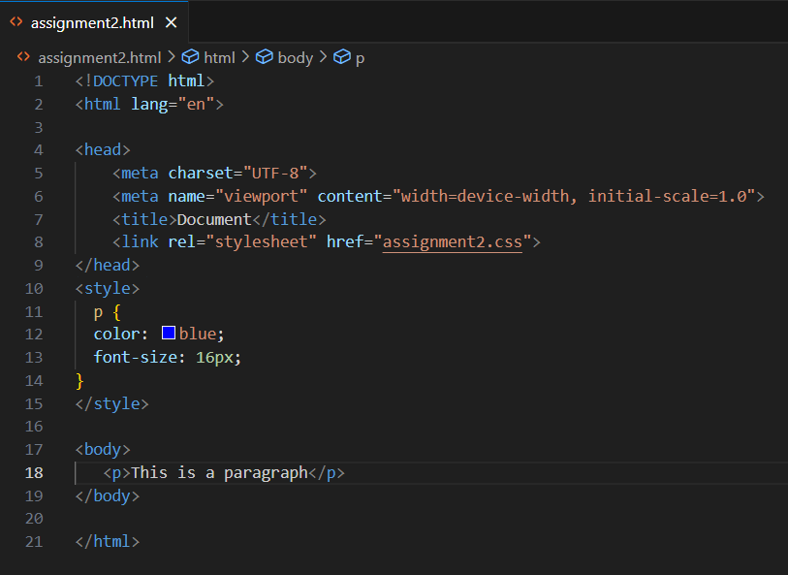

Q20. Create Layouts
Ans. Code file is available at GitHub in the same folder for below layout.

